

**考研英语小作文整理**

**考研英语一小作文汇总**

|  |  |  |
| --- | --- | --- |
| **年份** | **考查形式** | **主题** |
| 2005 | 辞职信 | 告诉老板辞职原因+表示歉意 |
| 2006 | 介绍信 | 申请资助贫困生候选人 |
| 2007 | 建议信 | 给大学图书馆提建议 |
| 2008 | 道歉信 | 就带走房东 CD 表示道歉+解决方案 |
| 2009 | 建议信 | 就白色污染提出建议 |
| 2010 | 招募通知 | 为全球化国际会议招募志愿者 |
| 2011 | 推荐信 | 推荐一部电影+给出原因 |
| 2012 | 建议信 | 欢迎留学生+就校园生活给出建议 |
| 2013 | 邀请信 | 邀请外教当英语演讲比赛评委 |
| 2014 | 建议信 | 就提高大学生身体状况向校长提出建议 |
| 2015 | 推荐信 | 推荐一本书+给出原因 |
| 2016 | 通知 | 告知新入学留学生图书馆相关信息 |
| 2017 | 推荐信 | 向教授推荐所在城市的景点+原因 |
| 2018 | 邀请信 | 邀请在校国际专家出席毕业典礼 |
| 2019 | 介绍信 | 向志愿者介绍“援建农村小学”项目 |
| 2020 | 通知 | 通知留学生即将举办的歌唱比赛 |
| 2021 | 建议信 | 向外国朋友就如何在中国找工作提建议 |
| 2022 | 邀请信 | 邀请外国教授组队参加国际创新大赛 |

**英语一小作文历年真题考查频率统计**

|  |  |  |
| --- | --- | --- |
| **题材** | **出现年份** | **考查次数** |
| 建议信 | 2007、2009、2012、2014、2021 | 5 |
| 推荐信 | 2011、2015、2017 | 3 |
| 邀请信 | 2013、2018、2022 | 3 |
| 辞职信 | 2005 | 1 |
| 道歉信 | 2008 | 1 |
| 介绍信 | 2006、2019 | 2 |
| 通知 | 2010、2016、2020 | 3 |

**考研英语二小作文汇总**

1



公众号：英语外刊精读笔记

|  |  |  |
| --- | --- | --- |
| **年份** | **考查形式** | **主题** |
| 2010 | 感谢信 | 感谢美国同事的款待+欢迎访问中国 |
| 2011 | 建议信 | 祝贺表弟/妹考上大学+给予建议 |
| 2012 | 投诉信 | 对从网店所购的电子词典给予投诉 |
| 2013 | 邀请信 | 邀请同学参加义卖会+介绍活动细节 |
| 2014 | 介绍信 | 请求舍友给予生活建议+自我习惯介绍 |
| 2015 | 通知 | 夏令营志愿者招聘 |
| 2016 | 建议信 | 感谢并提供翻译方面的建议 |
| 2017 | 介绍信 | 给留学生介绍中国文化 |
| 2018 | 道歉信 | 对取消行程表示歉意 |
| 2019 | 介绍信 | 就交通堵塞辩论给予一个主题 |
| 2020 | 建议信 | 向留学生介绍古迹+给出旅行建议 |
| 2021 | 邀请信 | 邀请留学生参加网络会议 |
| 2022 | 介绍信 | 向留学生介绍校园美食节 |

**英语二小作文历年真题考查频率统计**

|  |  |  |
| --- | --- | --- |
| **题材** | **出现年份** | **考查次数** |
| 建议信 | 2011、2016、2020 | 3 |
| 邀请信 | 2013、2021 | 2 |
| 感谢信 | 2010 | 1 |
| 投诉信 | 2012 | 1 |
| 介绍信 | 2014、2017、2019、2022 | 4 |
| 道歉信 | 2018 | 1 |
| 通知 | 2015 | 1 |

**考研英语一小作文(2005-2022)**

|  |  |  |
| --- | --- | --- |
| **时间** | **信件类型和内容** | **真题** |
| 2005 | 辞职信  1. 辞职，陈述原因  2. 道歉 | Two months ago you got a job as an editor for the magazine *Designs &*  *Fashions*. But now you find that the work is not what you expected. You decide to quit. Write a letter to your boss, Mr. Wang, telling him your decision, stating your reason(s), and making an apology. |

2

公众号：英语外刊精读笔记

|  |  |  |
| --- | --- | --- |
|  |  | Write your letter with no less than 100 words. Write it neatly on  ANSWER SHEET 2.  Do not sign your own name at the end of the letter; use “Li Ming”  instead.  You do not need to write the address. (10 points) |
| 2006 | 介绍信  介绍要资助儿童的特点+资助计划 | You want to contribute to Project Hope by offering financial aid to a child in a remote area. Write a letter to the department concerned, asking them to help find a candidate. You should specify what kind of child you want to help and how you will carry out your plan.  Write your letter in no less than 100 words. Write it neatly on  ANSWER SHEET 2.  Do not sign your own name at the end of the letter; use “Li Ming”  instead.  Do not write the address. (10 points) |
| 2007 | 建议信  建议大学图书馆提高服务质  量 | Write a letter to your university library, making suggestions for improving its service.  You should write about 100 words on ANSWER SHEET 2.  Do not sign your own name at the end of the letter. Use “Li Ming”  instead.  Do not write the address. (10 points) |
| 2008 | 道歉信  回国后发现忘记归还 Bob 唱片  提出解决办法 | You have just come back from Canada and found a music CD in your luggage that you forgot to return to Bob, your landlord there. Write him a letter to  1) make an apology, and  2) suggest a solution.  You should write about 100 words on ANSWER SHEET 2.  Do not sign your own name at the end of the letter. Use “Li Ming”  instead.  Do not write the address. (10 points) |
| 2009 | 建议信  简单介绍对“白色污染”的看法+提出建议 | Restrictions on the use of plastic bags have not been so successful in some regions. "White pollution "is still going on. Write a letter to the editor(s) of your local newspaper to  1) give your opinions briefly and  2) make two or three suggestions  You should write about 100 words. Do not sign your own name at the end of the letter. Use "Li Ming" instead. You do not need to write the address. |

3

公众号：英语外刊精读笔记

|  |  |  |
| --- | --- | --- |
| 2010 | 通知  针对“全球化”会议招募志愿者+志愿者应满足的条件 | You are supposed to write for the postgraduate association a notice to recruit volunteers for an international conference on globalization, you should conclude the basic qualification of applicant and the other information you think relative.  You should write about 100 words. Do not sign your own name at  the end of the letter. Use "postgraduate association" instead. |
| 2011 | 推荐信  写信给朋友推荐一部电影+推荐的原因 | Write a letter to a friend of yours to  1) recommend one of your favorite movies and  2) give reasons for your recommendation.  Your should write about 100 words on ANSWER SHEET 2  Do not sign your own name at the end of the letter. User “Li Ming”  instead.  Do not writer the address.(10 points) |
| 2012 | 建议信  对国际生表达欢迎+对他们的校园生活提出建议 | Some international students are coming to your university. Write them an email in the name of the Students’ Union to  1) extend your welcome and  2) provide some suggestions for their campus life here.  You should write about 100 words on ANSWER SHEET 2.  Do not sign your name at the end of the letter. Use “Li Ming”  instead.  Do not write the address. (10 points) |
| 2013 | 邀请信  邀请外籍教师担任英语口语  比赛的评委+必要的信息 | Write an e-mail of about 100 words to a foreign teacher in your college, inviting him/her to be a judge for the upcoming English speech contest.  You should include the details you think necessary. You should write neatly on the ANSWER SHEET 2.  Do not sign your own name at the end of the e-mail. Use “Li  Ming” instead.  Do not write the address. (10 points) |
| 2014 | 建议信  就增强学生体质提建议  +必要信息 | Write a letter of about 100 words to the president of your university, suggesting how to improve students’ physical condition.  You should include the details you think necessary.  You should write neatly on the ANSWER SHEET.  Do not sign your own name at the end of the letter. Use “Li Ming”  instead.  Do not write the address. (10 points) |
| 2015 | 推荐信  推荐一本书+推荐原因 | You are going to host a club reading session. Write an email of about  100 words recommending a book to the club members. You should state reasons for your recommendation. You should write neatly on the ANSWER SHEET.  Do not sign your own name at the end of the letter. Use “Li Ming”  instead.  Do not write the address. (10 points) |

4

公众号：英语外刊精读笔记

|  |  |  |
| --- | --- | --- |
| 2016 | 通知  介绍有关图书馆的信息 | Suppose you are a librarian in your university. Write a notice of about  100 words, providing the newly-enrolled international student with relevant information about the library.  You should write neatly on the ANSWER SHEET.  Do not sign your own name at the end of the notice. Use “Li  Ming” instead.  Do not write the address. (10 points) |
| 2017 | 介绍信  向外教介绍旅游景点+介绍原因 | You are to write an email to James Cook, a newly-arrived Australia professor, recommending some tourist attraction in your city. Please give reason for your recommendation.  You should write neatly on the ANSWER SHEET.  Do not sign your own name at the end of the email. Use “Li  Ming” instead.  Do not write the address. (10 points) |
| 2018 | 邀请信  邀请专家参加毕业典礼+典礼的时间、地点及其他必要信息 | Write an email to all international experts on campus, inviting them to attend the graduation ceremony. In your email, you should include the time, place and other relevant information about the ceremony.  You should write neatly on the ANSWER SHEET.  Do not sign your own name at the end of the email. Use “Li  Ming” instead.  Do not write the address. (10 points) |
| 2019 | 介绍信  介绍“援助乡村小学”项目 | Suppose you are working for the “Aiding Rural Primary School” project of your university. Write an email to answer the inquiry from an international student volunteer, specifying details of the project.  You should write neatly on the ANSWER SHEET.  Do not sign your own name at the end of the email. Use “Li  Ming” instead.  Do not write the address. (10 points) |
| 2020 | 通知  通知留学生即将举办的  歌唱比赛 | The Student Union of your university has assigned you to inform the international students about an upcoming singing contest. Write a notice in about 100 words.  Write your answer on the ANSWER SHEET.  Do not use your own name in the notice. (10 points) |
| 2021 | 建议信  向外国朋友就如何在中  国找工作提建议 | One foreign friend of your university graduated from college and intends to find a job in China. Please write an Email to him/her to make some suggestions.  You should write neatly on the ANSWER SHEET.  Do not sign your own name in the email. Use “Li Ming” instead. (10  points) |
| 2022 | 邀请信  邀请外国教授组队参加  国际创新大赛 | Write an Email to a professor at a British university, inviting him/her to organize a team for the international innovation contest to be held at your university. |

5

公众号：英语外刊精读笔记

You should write neatly on the ANSWER SHEET.

Do not sign your own name. Use “Li Ming” instead. (10 points)

**考研英语二小作文(2010-2022)**

|  |  |  |
| --- | --- | --- |
| **时**  **间** | **信件类型和内容** | **真题** |
| 2010 | 感谢信  感谢美国同事的热情款待+邀请美国同事来访 | You have just come back from the U.S. as a member of a Sino-American cultural exchange program. Write a letter to your American colleague to  1) express your thanks for his/her warm reception;  2) welcome him/her to visit China in due course.  You should write about 100 words on the Answer Sheet.  Do not sign your own name at the end of the letter. Use “Zhang Wei” instead.  Do not write your address. (10 points) |
| 2011 | 建议信  祝贺录取+就大学生活提建议 | Suppose your cousin Li Ming has just been admitted to a university. Write him/her a letter to  1) congratulate him/her, and  2) give him/her suggestions on how to get prepared for university life. You should write about 100 words on the Answer Sheet.  Do not sign your own name at the end of the letter. Use “Zhang Wei” instead.  Do not write the address. (10 points) |
| 2012 | 投诉信  提出投诉+要求解决 | Suppose you have found something wrong with the electronic dictionary that you bought from an online store the other day. Write an email to the customer service center to  1) make a complaint, and  2) demand a prompt solution.  You should write about 100 words on the Answer Sheet.  Do not sign your own name at the end of the letter. Use “Zhang Wei” instead.  Do not write the address. (10 points) |
| 2013 | 邀请信  邀请参加义卖+鼓励参与 | Suppose your class is to hold a charity sale for kids in need of help. Write your  classmates an email to  1) inform them about the details, and  2) encourage them to participate.  You should write about 100 words on the Answer Sheet. Do not use your own name. Use “Li Ming” instead.  Do not write your address. (10 points) |
| 2014 | 介绍信  介绍生活习惯+请求给建议 | Suppose you are going to study abroad and share an apartment with John, a local student. Write him an email to  1) tell him about your living habits, and  2) ask for advice about living there.  You should write about 100 words on the Answer Sheet. |

6

公众号：英语外刊精读笔记

|  |  |  |
| --- | --- | --- |
|  |  | Do not use your own name. Use “Li Ming” instead.  Do not write your address. (10 points) |
| 2015 | 通知  介绍夏令营的活动+招募志愿者 | Suppose your university is going to host a summer camp for high school  students. Write a notice to  1) briefly introduce the camp activities, and  2) call for volunteers.  You should write about 100 words on the Answer Sheet. Do not use your name or the name of your university. Do not write your address. (10 points) |
| 2016 | 建议信  表达感谢+提供翻译建议 | Suppose you won a translation contest and your friend, Jack, wrote an email to congratulate you and ask for advice on translation. Write him a reply to  1) thank him, and  2) give your advice.  You should write about 100 words on the Answer Sheet.  Do not sign your own name at the end of the letter. Use Li Ming instead.  Do not write the address. (10 points) |
| 2017 | 介绍信  接受邀请+介绍演讲信息 | Suppose you are invited by Professor Williams to give a presentation about  Chinese culture to a group of international students. Write a reply to  1) accept the invitation, and  2) introduce the key points of your presentation.  You should write about 100 words on the Answer Sheet. Do not use your own name. Use “Li Ming” instead.  Do not write your address. (10 points) |
| 2018 | 道歉信  道歉+建议未来会面 | Suppose you have to cancel your travel plan and will not be able to visit  Professor Smith. Write him an email to  1) apologize and explain the situation, and  2) suggest a future meeting.  You should write about 100 words on the Answer Sheet. Do not use your own name. Use “Li Ming” instead.  Do not write your address. (10 points) |
| 2019 | 介绍信  介绍辩论会主题+原因+辩论会安排 | Suppose professor Smith ask you to plan a debate on the theme of city traffic, write an email to him.  1) Suggest a topic and with your reasons,  2) And your arrangement.  You should write about 100 words on the ANSWER SHEET.  Don't use your own name. Use "Zhang Wei" instead. Don't write your address.  (10 points) |
| 2020 | 建议信  介绍古迹+给出游览建议 | Suppose you are planning a tour of a historical site for a group of international students. Write an email to  1) tell them about the site, and  2) give them some tips for the tour.  Please write your answer on the ANSWER SHEET.  Don't use your own name. Use "Li Ming" instead. (10 points) |

|  |  |  |
| --- | --- | --- |
| 2021 | 邀请信  邀请留学生参加网  络会议 | Suppose you are organizing an online meeting. Write an email to Jack, an  international student, to  1) invite him to participate, and  2) tell him the details.  You should write about 100 words on the ANSWER SHEET.  Don't use your own name. Use "Zhang Wei" instead. (10 points) |
| 2022 | 介绍信  向留学生介绍校园  美食节 | Suppose you are planning a campus food festival. Write an email to the international students in your university to  1) introduce the food festival, and  2) invite them to participate.  You should write about 100 words on the ANSWER SHEET.  Do not use your own name in the email; use “Li Ming” instead. (10 points) |

**考研英语大作文整理（英一+英二）**

**英语一历年真题话题统计及分类**

|  |  |  |
| --- | --- | --- |
|  | **图片题目** | **主题** |
| **成功**  **品质** | 2003 年：温室花朵经不起风雨 | 独立 |
| 2004 年：终点又是新的起点 | 不断努力 |
| 2007 年：守门员 | 自信 |
| 2008 年：你一条腿，我一条腿；你我一起，走南  闯北 | 合作 |
| 2012 年：乐观与悲观 | 乐观 |
| 2013 年：毕业生的选择 | 正确选择 |
| 2016 年：与其只提要求，不如做个榜样 | 榜样 |
| 2017 年：“有书”与“读书” | 行动、读书 |
| 2018 年：选课进行时 | 勇于面对困难 |
| 2019 年：途中 | 坚持、鼓励 |
| 2020 年：习惯 | 培养良好的习惯、学会时  间管理 |

9



|  |  |  |
| --- | --- | --- |
|  | 2021 年：无 | 自信 |
|  | 2022 年：无 | 求知 |
| **道德**  **品质** | 2001 年：爱心是一盏灯 | 爱心 |
| 2005 年：养老“足球赛” | 孝顺 |
| 2014 年：相携 | 孝顺 |
| **社会**  **文化** | 2002 年：穿中国服饰的美国女孩 | 民族文化 |
| 2010 年：文化“火锅”，既美味又营养 | 文化融合 |
| 2006 年：花 300 元做个“小贝”头 | 合理的偶像崇拜 |
| **科技**  **应用** | 2009 年：网络的“近”与 “远” | 适度使用网络 |
| 2015 年：手机时代的聚会 | 适度使用手机 |
| **环境**  **保护** | 2000 年：过度捕捞 | 环境保护、保护自然资源 |
| 2011 年：旅程之“余” | 环境保护 |
|  |  |  |

|  |  |
| --- | --- |
| 2000 年 |  |
| 2001 年 |  |
| 2002 年 | An American girl in traditional Chinese costume (服装) |
| 2003 年 |  |

1

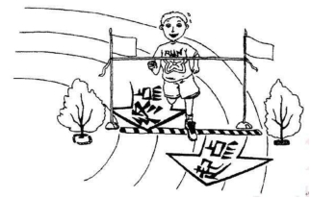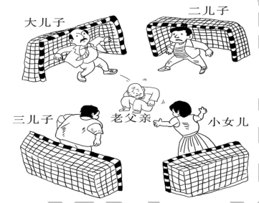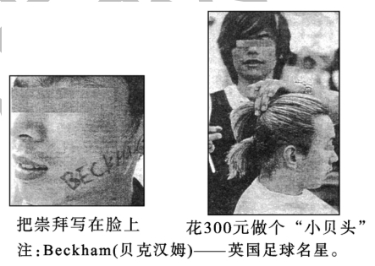

|  |  |
| --- | --- |
|  | 温室的花朵经不起风雨 |
| 2004 年 |  |
| 2005 年 | 养老足球赛 |
| 2006 年 |  |

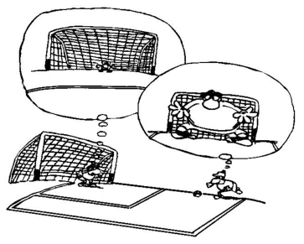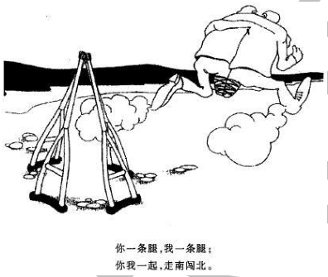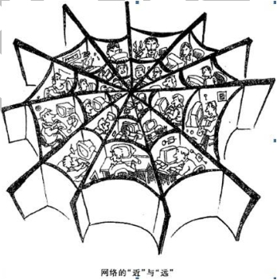

|  |  |
| --- | --- |
| 2007 年 |  |
| 2008 年 |  |
| 2009 年 | 网络的“近”与“远” |

13

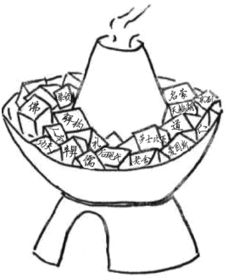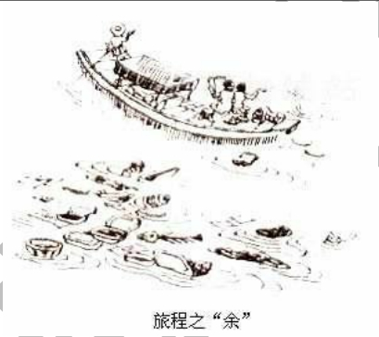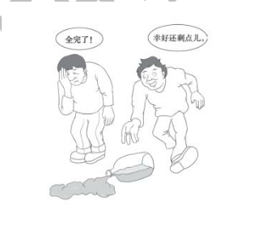

公众号：英语外刊精读笔记

|  |  |
| --- | --- |
| 2010 年 | 文化“火锅”，既美味又营养 |
| 2011 年 |  |
| 2012 年 |  |

14

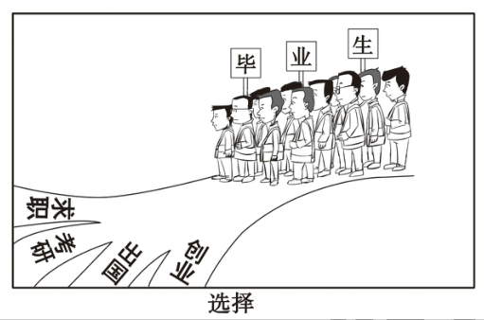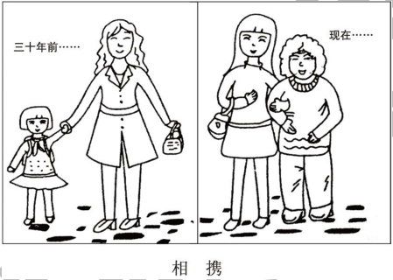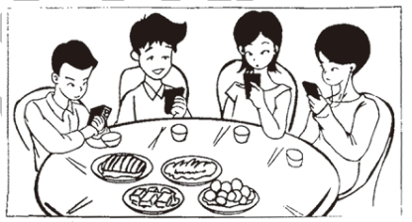

|  |  |
| --- | --- |
| 2013 年 |  |
| 2014 年 |  |
| 2015 年 | 手机时代的聚会 |

15

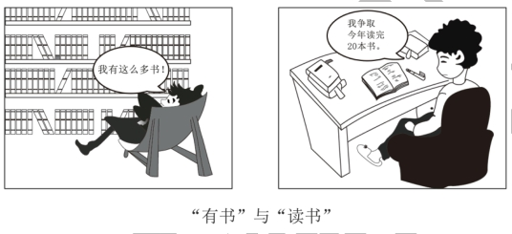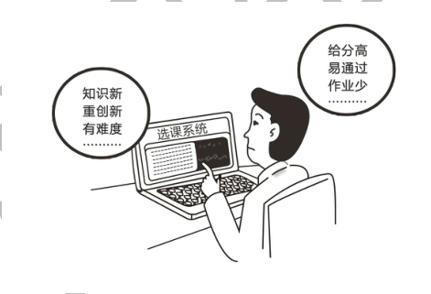

公众号：英语外刊精读笔记

|  |  |
| --- | --- |
| 2016 年 | **与其只提要求，不如做个榜样** |
| 2017 年 |  |
| 2018 年 | 选课进行时 |

16

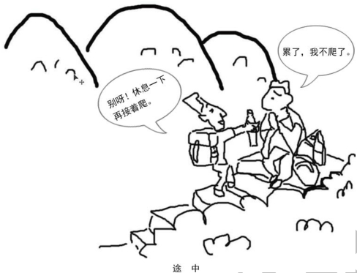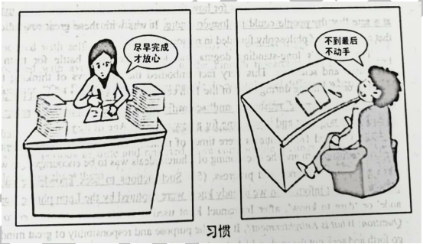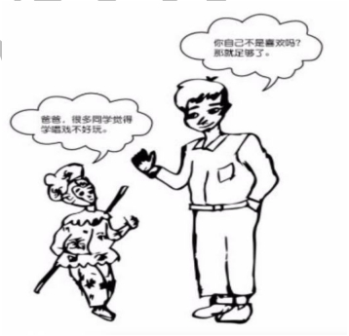

公众号：英语外刊精读笔记

|  |  |
| --- | --- |
| 2019 年 |  |
| 2020 年 |  |
| 2021 年 |  |
| 2022年 |  |

**英语二历年真题话题归类**

|  |  |
| --- | --- |
| **真题** | **话题归类** |
| 2010 年：发展中国家手机入网 | 经济消费类 |
| 2011 年：2008 年、2009 年国内轿车市场部分品牌市场份额示意图 | 经济消费类 |
| 2012 年：某公司员工工作满意度调查 | 社会文化类 |
| 2013 年：某高校学生兼职情况 | 大学生活类 |
| 2014 年：20 年间中国城镇人口与乡村人口变化图 | 经济消费类 |
| 2015 年：我国某市居民春节假期花销比例 | 经济消费类 |
| 2016 年：某高校学生旅游目的调查 | 大学生活类 |
| 2017 年：2013-2015 年我国博物馆数量和参观人数 | 社会文化类 |
| 2018 年：2017 年某市消费者选择餐厅时的关注因素 | 经济消费类 |

18

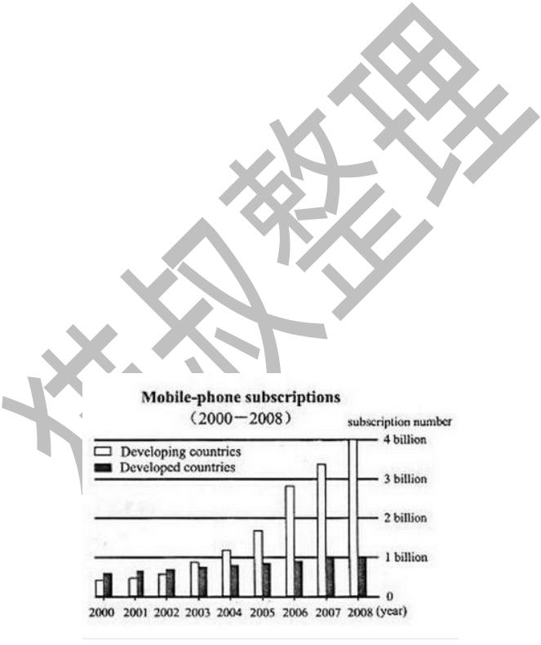

公众号：英语外刊精读笔记

|  |  |
| --- | --- |
| 2019 年：2013 年和 2018 年本科毕业生毕业去向 | 大学生活类 |
| 2020 年：某高校学生手机阅读目的调查 | 大学生活类 |
| 2021 年：某市居民锻炼方式调查 | 社会文化类 |
| 2022 年：中国快递业务量的变化情况 | 社会文化类 |

**英语二历年真题汇总（2010年-2022年）**

**2010年**

**Directions**:

Write an essay based on the following chart. In your writing, you should

1) interpret the chart, and

2) give your comments.

You should write about 150 words on the ANSWER SHEET. (15 points)

**Mobile-phone Subscriptions (2000-2008)**

19

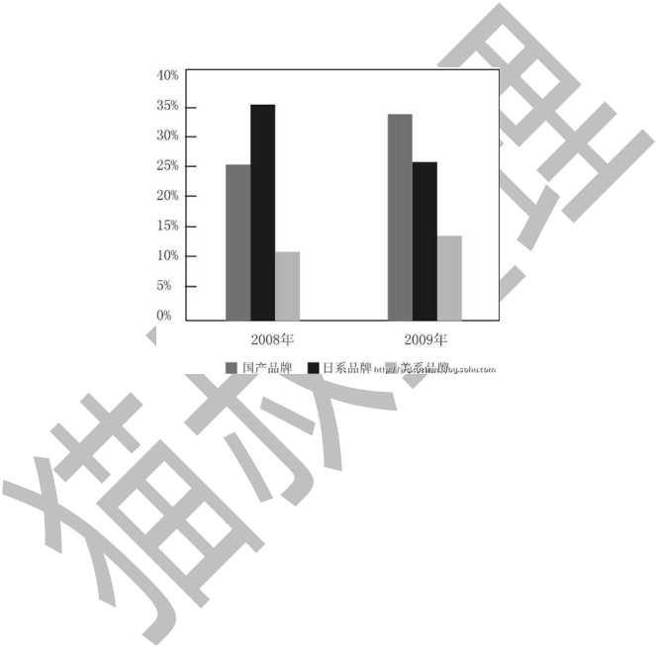

公众号：英语外刊精读笔记

**2011年**

**Directions**:

Write an essay based on the following chart. In your writing, you should

1) interpret the chart, and

2) give your comments.

You should write about 150 words on the ANSWER SHEET. (15 points)

**2008年、2009年国内轿车市场部分品牌市场份额示意图**

**2012年**

**Directions**:

Write an essay based on the following table. In your writing, you should

1) describe the table, and

2) give your comments.

You should write about 150 words on the ANSWER SHEET. (15 points)

20

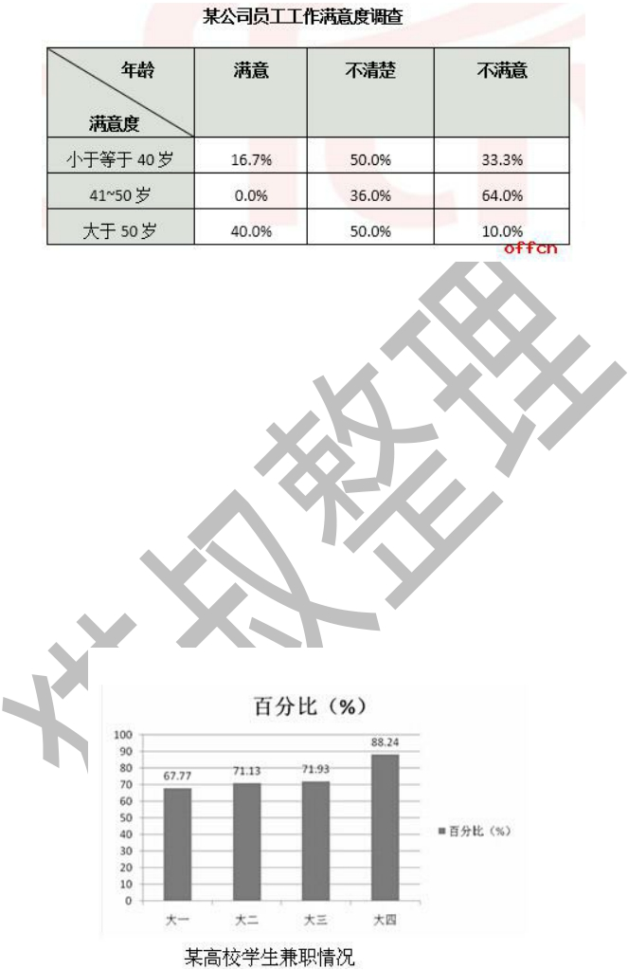

公众号：英语外刊精读笔记

**2013年**

**Directions**:

Write an essay based on the following chart. In your writing, you should

1) interpret the chart, and

2) give your comments.

You should write about 150 words on the ANSWER SHEET. (15 points)

**2014年**

21

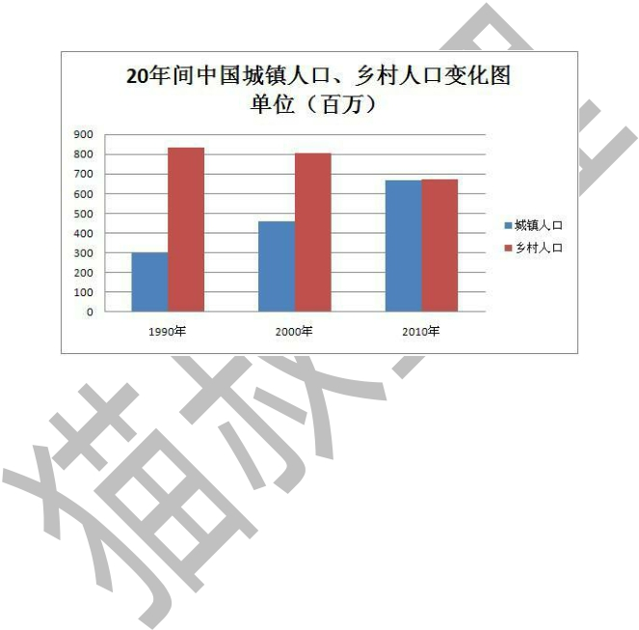

公众号：英语外刊精读笔记

**Directions**:

Write an essay based on the following chart. In your writing, you should

1) interpret the chart, and

2) give your comments.

You should write about 150 words on the ANSWER SHEET. (15 points)

**2015年**

**Directions**:

Write an essay based on the following chart. In your writing, you should

1) interpret the chart, and

2) give your comments.

You should write about 150 words on the ANSWER SHEET. (15 points)

22

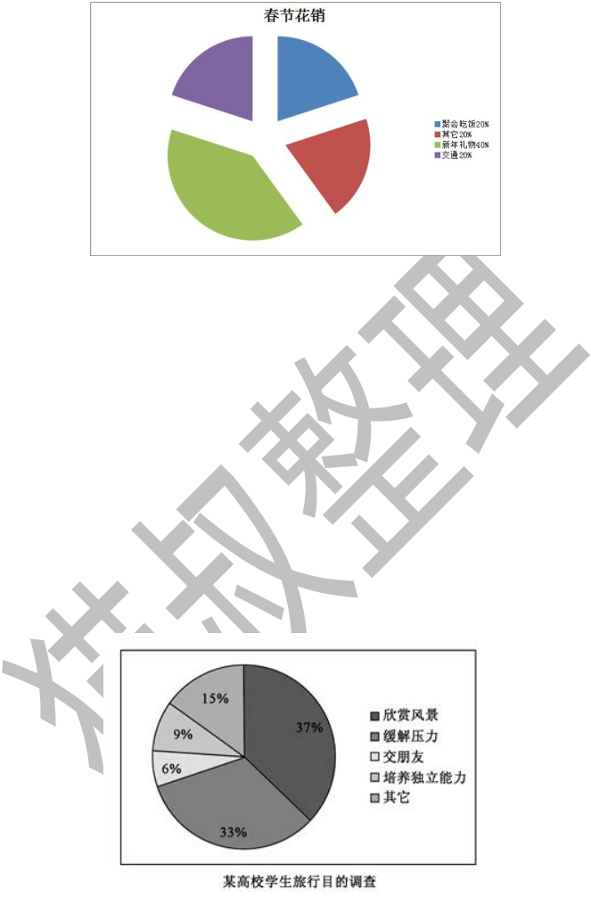

公众号：英语外刊精读笔记

**我国某市居民春节假期花销比例**

**2016年**

**Directions**:

Write an essay based on the following chart. In your writing, you should

1) interpret the chart, and

2) give your comments.

You should write about 150 words on the ANSWER SHEET. (15 points)

**2017年**

**Directions**:

23

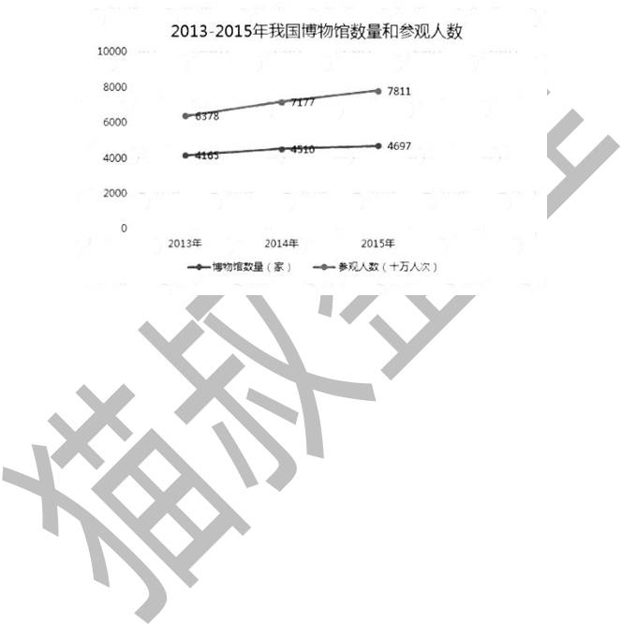

公众号：英语外刊精读笔记

Write an essay based on the following chart. In your writing, you should

1) interpret the chart, and

2) give your comments.

You should write about 150 words on the ANSWER SHEET. (15 points)

**2018年**

**Directions**:

Write an essay based on the following chart. In your writing, you should

1) interpret the chart, and

2) give your comments.

You should write about 150 words on the ANSWER SHEET. (15 points)

24

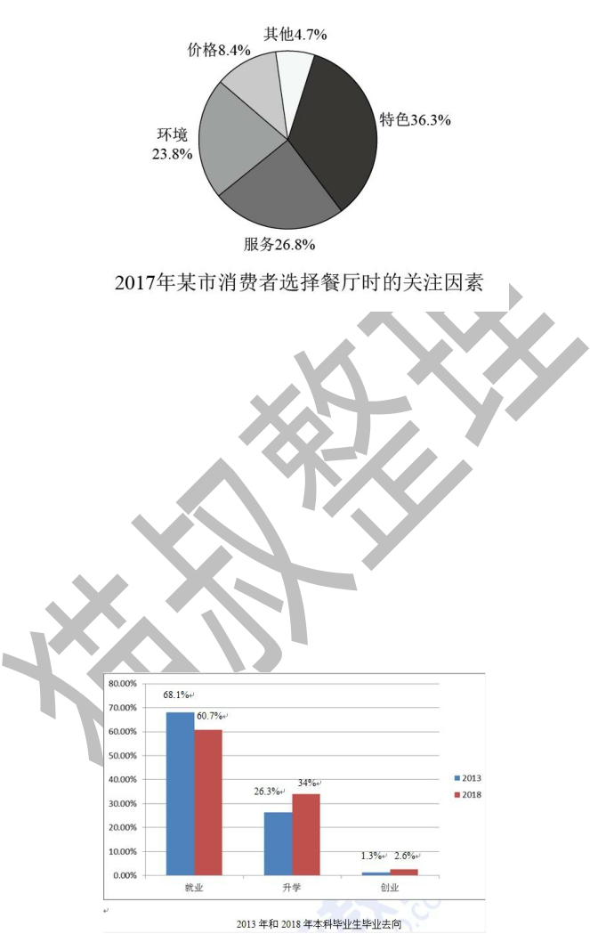

公众号：英语外刊精读笔记

**2019年**

**Directions**:

Write an essay based on the following chart. In your writing, you should

1) interpret the chart, and

2) give your comments.

You should write about 150 words on the ANSWER SHEET. (15 points)

25

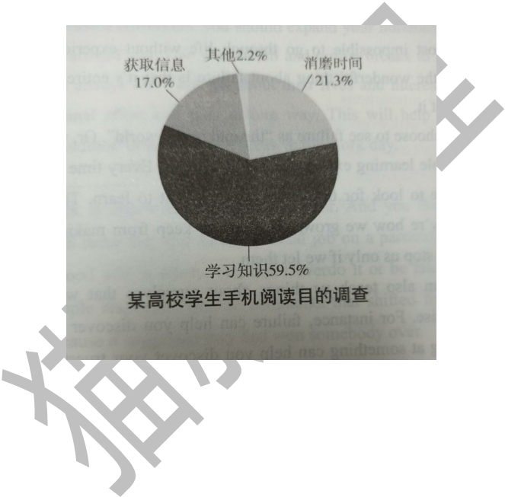

公众号：英语外刊精读笔记

**2020年**

**Directions**:

Write an essay based on the chart below. In your writing, you should

1) interpret the chart, and

2) give your comments.

You should write about 150 words on the ANSWER SHEET. (15 points)

**2021年**

**Directions**:

Write an essay based on the chart below. In your writing, you should

1) interpret the chart, and

2) give your comments.

You should write about 150 words on the ANSWER SHEET. (15 points)

26

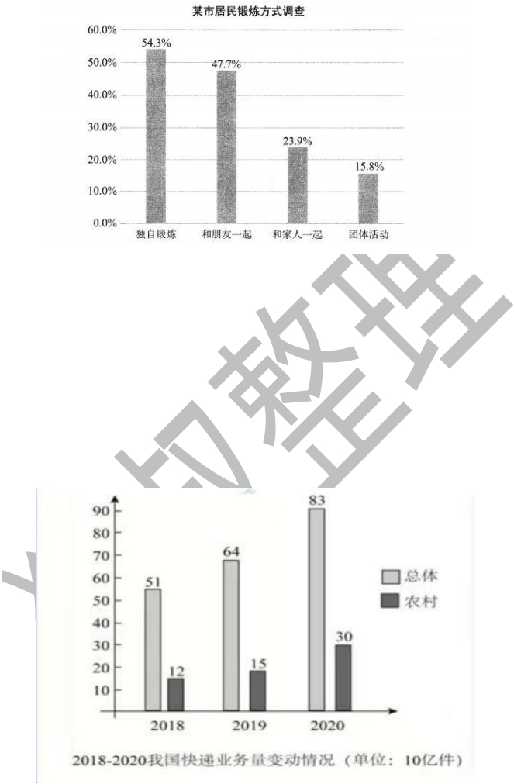

公众号：英语外刊精读笔记

**2022年**

**Directions**:

Write an essay based on the chart below. In your writing, you should

1) interpret the chart, and

2) give your comments.

You should write about 150 words on the ANSWER SHEET. (15 points)

27